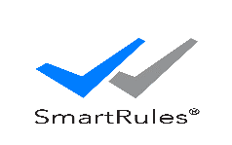

**User Manual - Rule Engine**

**DOCUMENT VERSION – 1.0**

**28-July-2022**

**DOCUMENT HISTORY**

|  |  |  |  |
| --- | --- | --- | --- |
| **Date** | **Version** | **Document Revision Description** | **Document Author** |
| 24-Feb-2021 | 0.01 | Initial version | Indumathi.P |
| 15-Apr-2021 | 0.02 | Added the Interface Diagram | Indumathi.P |
| 12-July-2022 | 0.03 | Updated for Latest changes | Indumathi.P |
| 20-July-2022 | 0.04 | Updated maker checker access permission changes, added details of rule group, rule utility | Hinduja Dasarathan |
| 27-July-2022 | 0.05 | Incorporated the Review comments | Hinduja Dasarathan |
| 28-July-2022 | 1.0 | Baselined version | Hinduja Dasarathan |

Table of Contents

1. Introduction 5

1.1 Purpose of this Solution 5

2. Solution Overview 5

2.1 Rule Engine Definition 6

2.2 Solution Details 6

2.3 Advantages of having Rule Engine 7

2.4 Access Permissions covered in this application 7

2.4.1 Access Permissions covered in this application 9

3. Rule Engine Web Component Overview 10

3.1 Domain Business Creation and Mapping 11

3.2 Parameter Master 12

3.2.1 Parameter - Edit 14

3.2.2 Parameter - Approve 14

3.3 Rule Creation – Define Rules 15

3.3.1 Send Rule for Approval 17

3.3.2 Rule Changes Approval Screen 18

3.3.3 Approved Rules 18

3.4 Rule Utility 19

3.4.1 Rule Utility - Create 19

3.4.2 Send Rule Utility for Approval 21

3.4.3 Rule Utility Changes Approval Screen 21

3.4.4 Approved Rule Utilities 22

3.5 Group Rule 22

3.5.1 Group Rule - Create 22

3.5.2 Send Group Rule for Approval 24

3.5.3 Group Rule Changes Approval Screen 24

3.5.4 Approved Group Rules 24

3.6 Simulator 25

3.7 Role Management 27

3.7.1 Role – Create / Edit 27

3.7.2 Role Approval Screen 29

3.7.3 Approved Roles 29

3.8 User Management 30

3.8.1 User - Create 30

3.8.2 User – Approval Screen 30

3.8.3 Approved Users 31

4. Rule Engine Execute Rule API 32

4.1 Single Rule Execution – Sample Input and output 32

4.1.1 Single Rule Execution – Sample Input and output (Success Scenario) 32

4.1.2 Single Rule Execution – Sample Input and output (Failure Scenario) 33

4.2 Multiple Rule Execution – Sample Input and output 34

4.2.1 Multiple Rule Execution – Sample Input and output (Success Scenario) 35

4.2.2 Multiple Rule Execution – Sample Input and output (Failure Scenario) 36

5. Rule Engine Dashboard 38

6. Rule Engine Reports 41

6.1 Number of Rules configured Report 41

6.2 Frequently Used Rule Report 41

6.3 Failure Analysis Report 42

6.4 Lead Generation Report 43

7. Security 45

8. System Requirement 45

8.1 Hardware and Software Requirement for Rule Engine 45

# Introduction

The purpose of this document is to describe the how to use the features and functionalities available in Rule Engine.

## Purpose of this Solution

Rule Engine enables policies or operational decisions to be defined, tested, executed and maintained separately from Application code.

Rule Engine has a web-based component specifically designed to aid developers or support engineers to do easy configuration and enables the easy change management process.

# Solution Overview

The Rule Engine has the following three functional components

1. Web-Based User Interface to Configure Rules
2. The APIs to execute the Rules [that can be integrated to invoke the configured Rules by any System]
3. Reports to view about the Rules

This integrated web-based application helps developers, Business users and support engineers to configure the Rules easily. In addition, it has a feature to view the reports.

The rules configured can be executed by the end-systems to get the output after applying the rules.

## 2.1 Rule Engine Definition

Rule engine serves as pluggable software component which execute business rules as an approach that is externalized or separated from application code. This externalization or separation allows business users to modify the rules without the need for IT intervention.

* Rule Engine tells what to do in any situation (not how to do).
* It gets data as input and gives the recommendation based on Rule Definition.

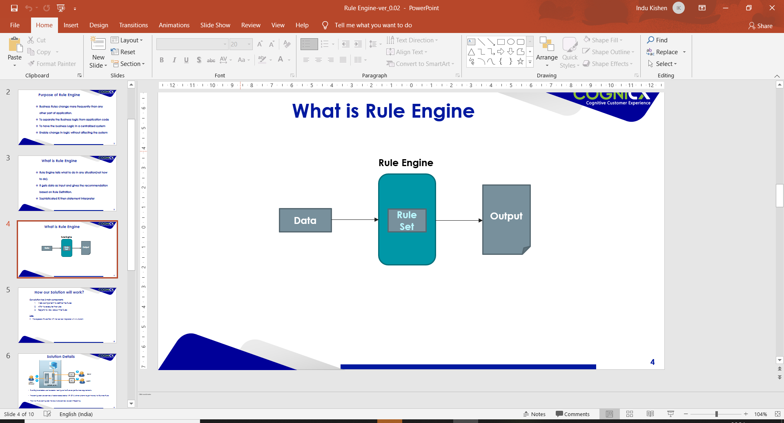

* Sophisticated if/then statement interpreter

## 2.2 Solution Details

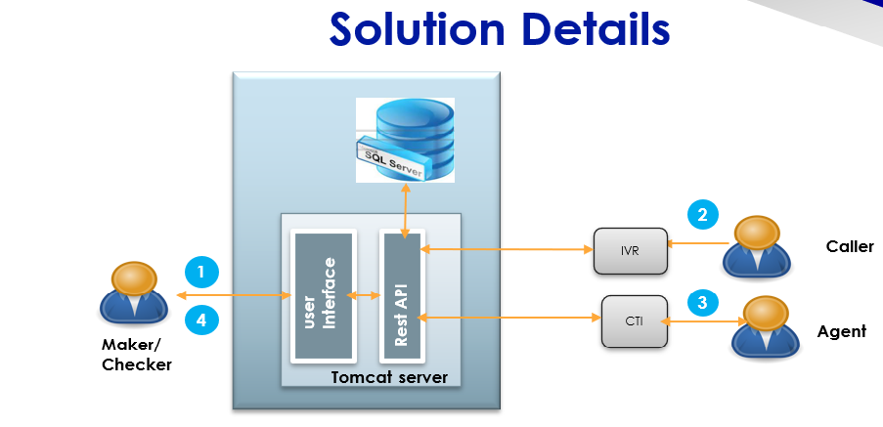

1. Rule Engine enables user to create / configure the Rules as per Business requirements through the user Interface.
2. The configured rules can be utilized or executed by IVR and caller can hear the IVR output / flow as per the result of executed Rules.
3. Similarly, CTI & other systems can execute the Rules to get the result of Business Rules
4. The list of Rules configured, the results etc. can be viewed as a part of Reporting.

## 2.3 Advantages of having Rule Engine

Having Rule Engine as a part of any business solution has the following advantages

**Greater Flexibility**: Keeping the rules in the Rule Engine allows to update / change rules easily without impact on other components.

**Easier to understand**: Rules defined in Rule Engine is Easier to understand compared to any procedural code as it is very close to natural language.

**Reduced Complexity:** As rule engine has the consistent representation of business rules, even complex rules can be easily interpreted.

**Explanation Facility**: Rule engine provides effective explanation facility, by being able to log the decisions made by Rule Engine along with why the decisions are made.

**Reusability**: Keeping the Rules in one place leads to a greater reusability of business rules. For example, the business rule defined can be used by both IVR, Agent desktop or any other system.

## 2.4 Access Permissions covered in this application

Below table has the list of access permissions that can be associated with the roles played by the users who are accessing the application and their responsibility along with the frequency in which they access the application (in the current process). However, the application can be accessed anytime from anywhere if they have their valid credentials and the application URL is not restricted by the network in which they try to access the application.

Roles can be configured and managed by the Role Management feature. Each Role can be assigned a set of access permissions (Read, Maker and Checker) for each of the components say Parameter, Rules, Rule Utility, Rule Groups, User Management, Role Management and Reports.

| **Access Permission** | **Example** | **Frequency of usage** | **Security/Access, Features Used** | **Additional Notes / Remarks** |
| --- | --- | --- | --- | --- |
| Read | People who would like to view the details of the components, say view list of parameters or defined rules | Whenever required | The Read access will allow only viewing the details of the components. The user with role having this access cannot manipulate it. |  |
| Maker | People who would like to define the components, say create parameter, rule, rule group or rule utility | Whenever required | The Maker access will allow defining new components say parameter/rule/rule group/rule utility and also edit already defined components. | Any component that is created or edited needs to be submitted for approval and becomes available for execution only if it gets approved.  In case of parameters, only approved parameters can be used in the rule definitions. |
| Checker | People who are authorized to approve the defined/edited components, say parameter/rule/rule group/rule utility | Whenever required | The checker access allows to approve / Reject the parameter/rule/rule group/rule utility or send approved rules for rework/ | Any component that is created by one user cannot be approved by the same user. This ensures additional security via proper validation by another user who approves the same. |

### 2.4.1 Access Permissions covered in this application

This access permission is applicable for managing Domain, Business Unit, Category and Channel. User having the role associated with this access can create/map the domain, business unit, category and channel for the other users to start using the rule engine.

| **Sample Roles** | **Example** | **Frequency of usage** | **Security/Access, Features Used** | **Additional Notes / Remarks** |
| --- | --- | --- | --- | --- |
| Admin | People who have access to all the screens and modules of user management, role management and reports | Whenever required | The admin can create/approve/reject roles/users, map users with appropriate roles, required Domain, Business Units. | The admin role can be given read, maker and checker access for user and role management |
| IT Maker / IT Checker | People who manage parameters involved in defining rules | Whenever required | The IT user roles can create/approve/reject the parameters required for defining rules  . | This role can be given combinations read/maker/checker.  For example, an IT Maker can have read/maker access, another role IT Checker can have read/checker access. |
| Business Maker / Business Checker | People who have access manage rule/rule group/rule utility. They can also do execution of the same | Whenever required | The business user roles can create/approve/reject and simulate rule/rule group/rule utility. | This role can be given combinations read/maker/checker.  For example, Business Maker can have read/maker access, another role Business Checker can have read/checker access. |

# Rule Engine Web Component Overview

This section covers overview of the Rule Engine. The web-based application enables user to create rules as per the business requirement.

The rules can be defined by the user, and should be approved to make it usable.

**Steps involved in Rule creation**

1. Create and Map Domain and Business Units, Category and Channels for particular customer. This will be done by user having super admin access
2. A user with role having maker access for parameter module, can create parameters associated with Domain and Business Units
3. The required parameters to be used by Rules should be created and approved.
4. In Rule Definition Work Area, a user having maker access for this module, can create rules for the Domain and Business Unit
5. Once Rules are created, it can be sent for approval to the checker
6. The user with checker access for the rule module can approve/ Reject / send for rework along with comments
7. The approved rules can be seen in the approved rule definition page by users having read access for the approved rules module in their role. If the role has maker access, then the approved rules can be edited for rework if needed and sent again for approval.
8. The approved rules can be executed and tested in the simulator page provided or can be executed by any software components that are approved to execute the Rule.

## 3.1 Domain Business Creation and Mapping

Master Data Domain, Business Units, Categories Types, and Channel Types are created in manage master data Page. 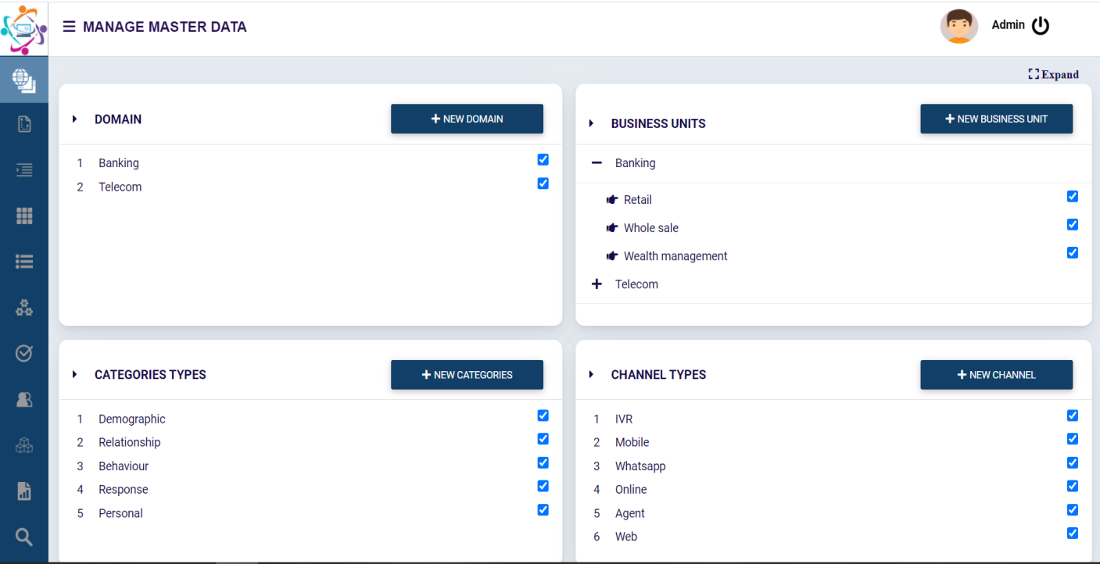

Categories are being mapped to each Domain and Business Units in domain and business units mapping Page.

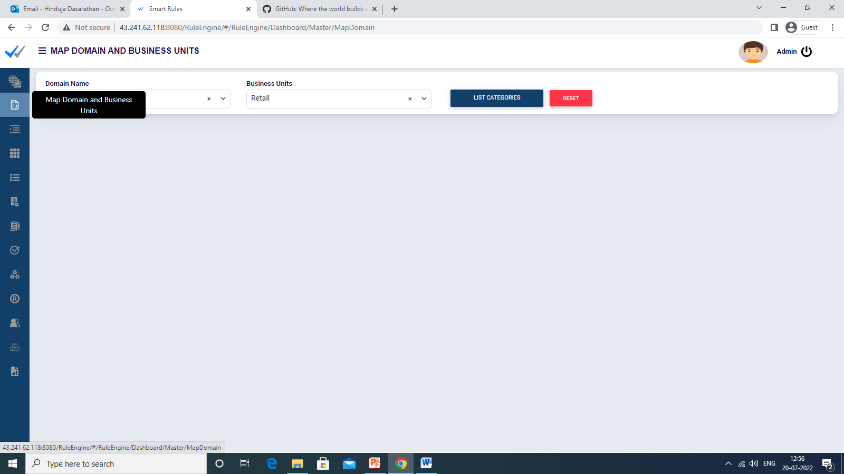

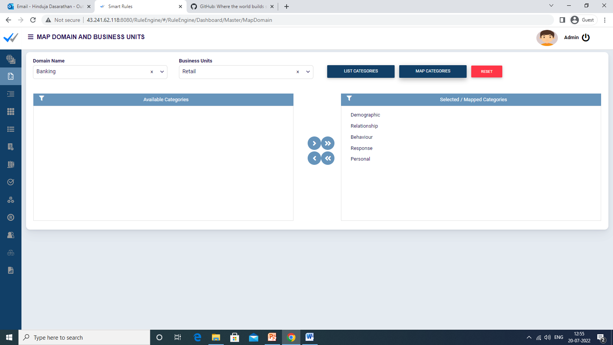

## 3.2 Parameter Master

Parameter Master will list the already created and approved parameters in the system. On click of add new parameter, it enables user to create the parameters based on domain and Business unit selected. And these parameters will be automatically sent for approval. Once approved by user having checker access in their role, it can be used to define the rules.

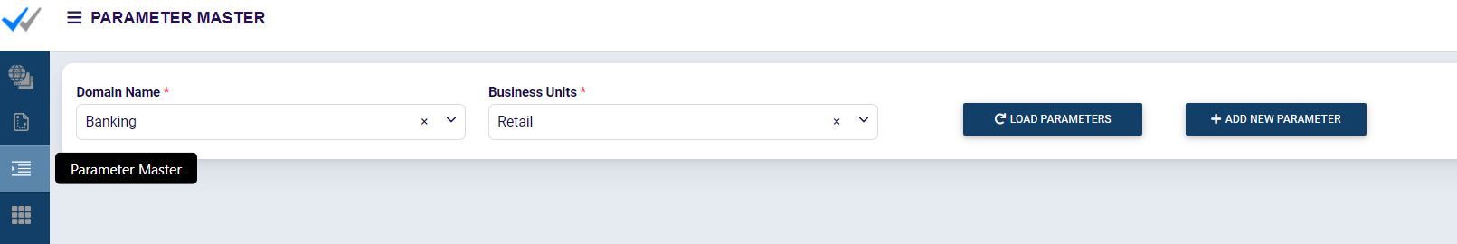

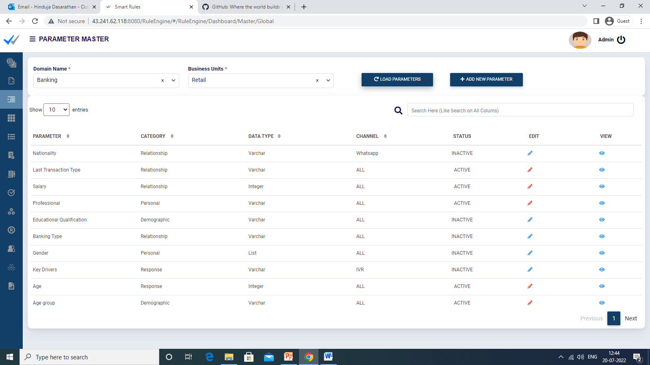

While adding a parameter, user can provide a name for the parameter, choose the associated category and channel Type. And the datatype of the parameter can also be defined.

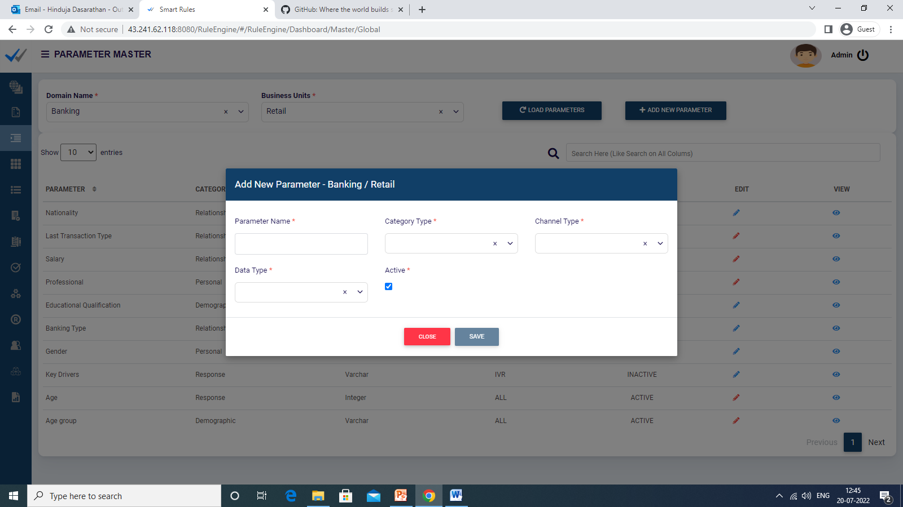

Once created, the parameter is automatically sent for approval. After approval it can be used in rule definition.

### 3.2.1 Parameter - Edit

A parameter can be made edited, status can be made INACTIVE to temporarily disable it for use in rule definitions. It can be made ACTIVE at any time later. The changes in the Edit page are automatically resent for approval, if rejected the old state will remain.

### 3.2.2 Parameter - Approve

The parameters to be approved will be listed to the user having checker privileges, from where the user can approve or reject it.

If any user has both maker and checker access for parameter module, the parameters created by other users will only be listed for this user to approve. Hence, this user can only approve the parameters created by others not his own. If he creates any parameter that should be approved by any other user who is having access this module with checker privileges.

Any new parameter that gets rejected will not be available in the system.

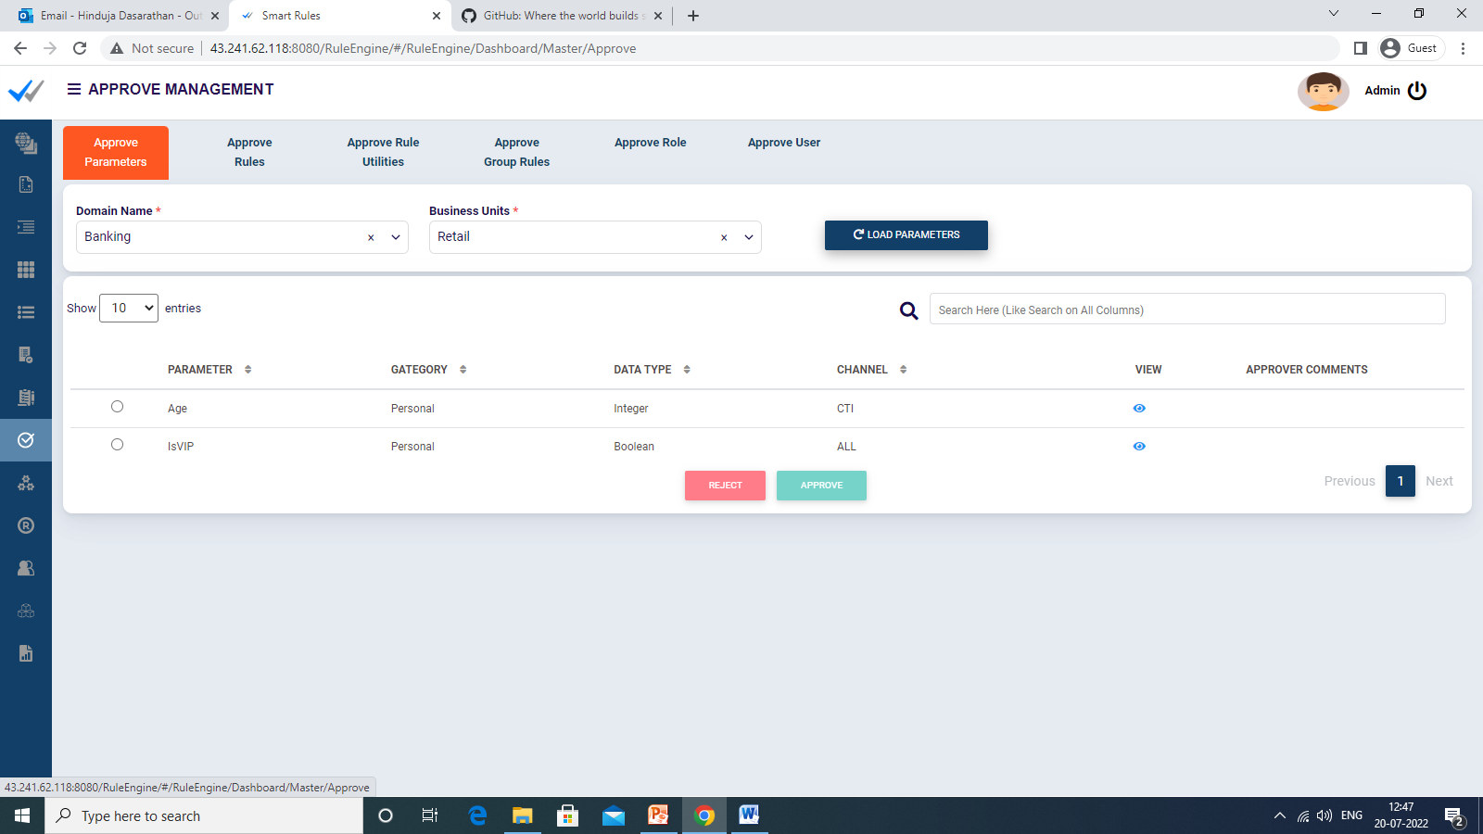

## 3.3 Rule Creation – Define Rules

A rule can be created by clicking on [Define Rules] Icon.

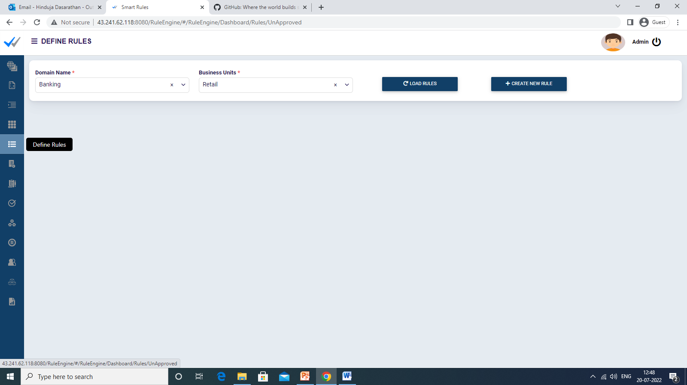

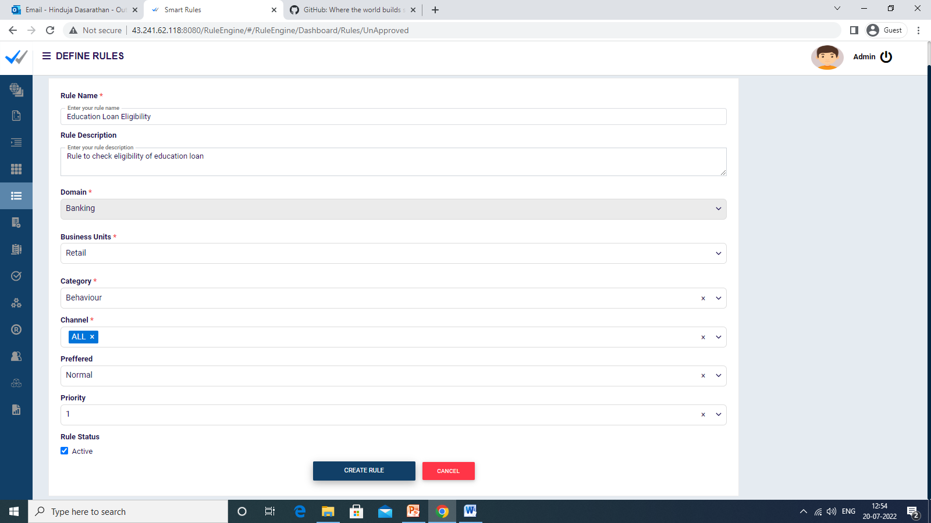

To create the Rules follow enter the below values

1. Specify the Rule name
2. Specify the Rule Description
3. Choose the Domain from the drop down
4. Choose the Business Unit from the drop down
5. Choose the category and Channel
6. Specify the type of rule, preferred or normal
7. Specify the priority

Once you specify above details, the created rule will be listed in the rule definition area as below.

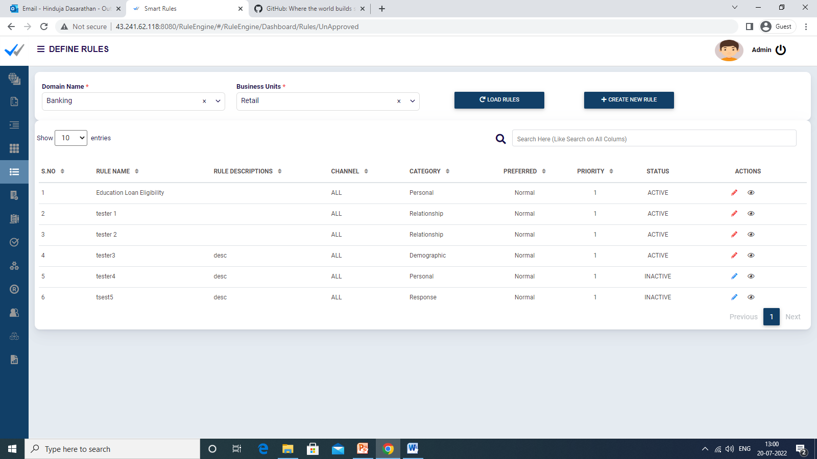

1. Choose the icon to Edit to define the rule further and where we can provide the rule criteria using active approved parameters.



1. Rule Edit Screen. 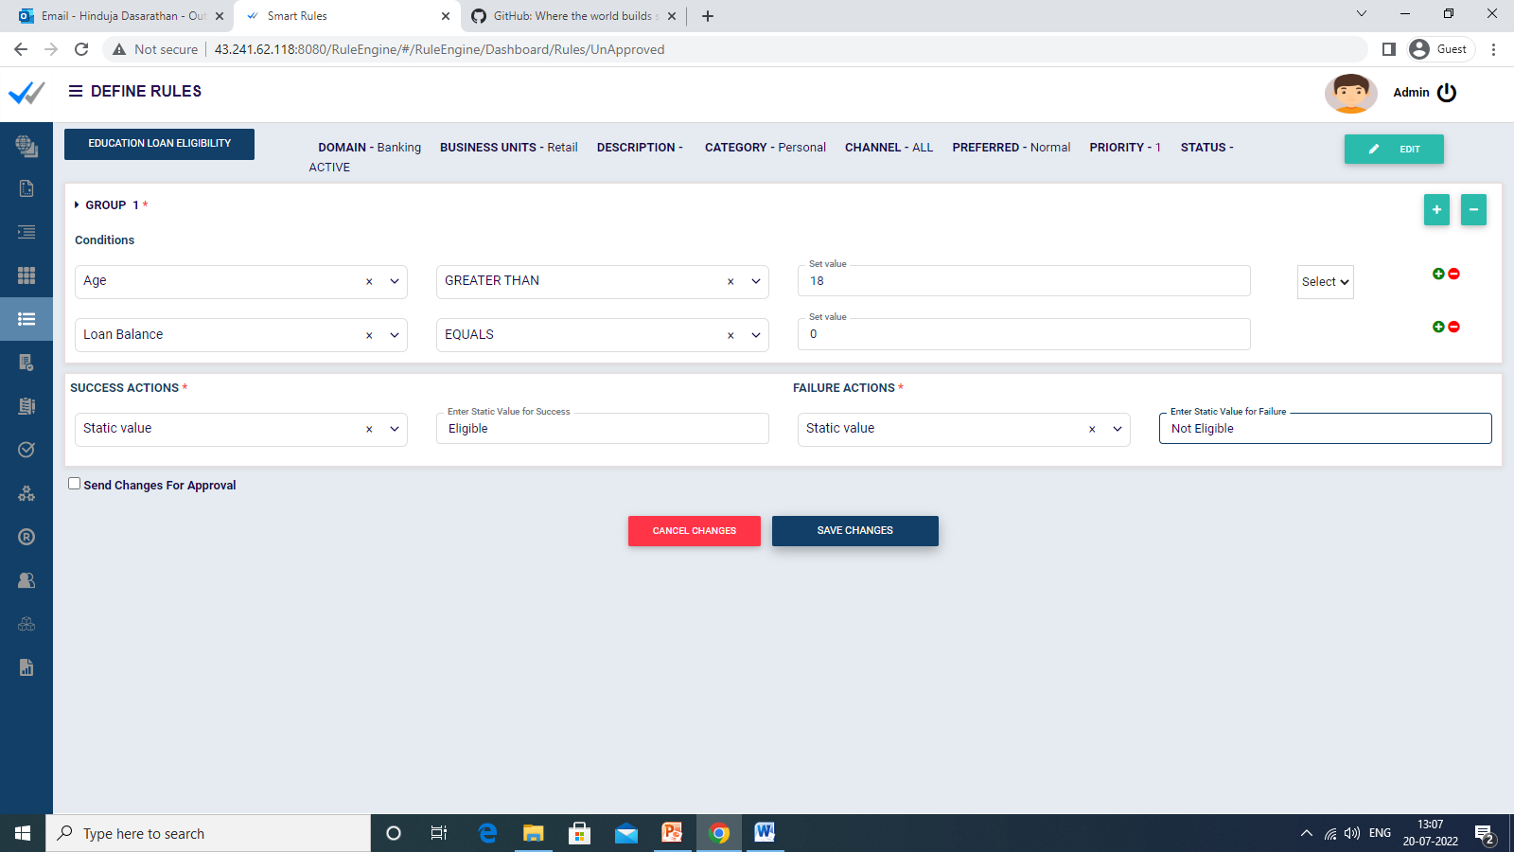

### 3.3.1 Send Rule for Approval

On Click of send changes for approval in rule edit page, it will be sent for approval. This rule can be approved by another user who has the checker access in role.



### 3.3.2 Rule Changes Approval Screen

In rule Changes Approval Screen, the rules to be approved by user with checker access will be listed, from where the user can approve, reject, or send it back for rework. Similar to parameters, if the user has both maker and checker access, this approval list will have the rules created by other users only.

Any new rule that gets rejected will not be available.

Any approved rule that is sent for approval upon edit, if rejected will remain in the old state.

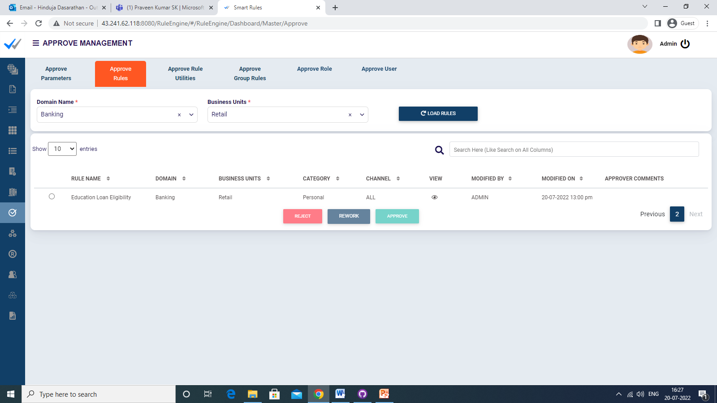

### 3.3.3 Approved Rules

Approved list rule Definition screen will list the already approved rules in the system and on click of edit enables user to edit the rule and criteria defined.

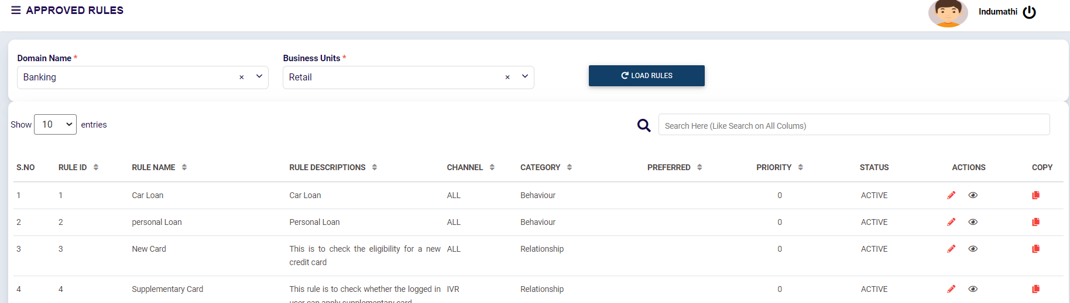

## 3.4 Rule Utility

It is a quick way to define rules involving two parameters in two-dimension matrix. The row and column values with the output corresponding to that condition can be defined in a table. While executing, the rule engine takes the input for the row and column parameter from the user and returns the appropriate result for the same.

### 3.4.1 Rule Utility - Create

Rule Utility can be created by clicking on ‘Create New Utility’ under the Unapproved Rule Utilities tab.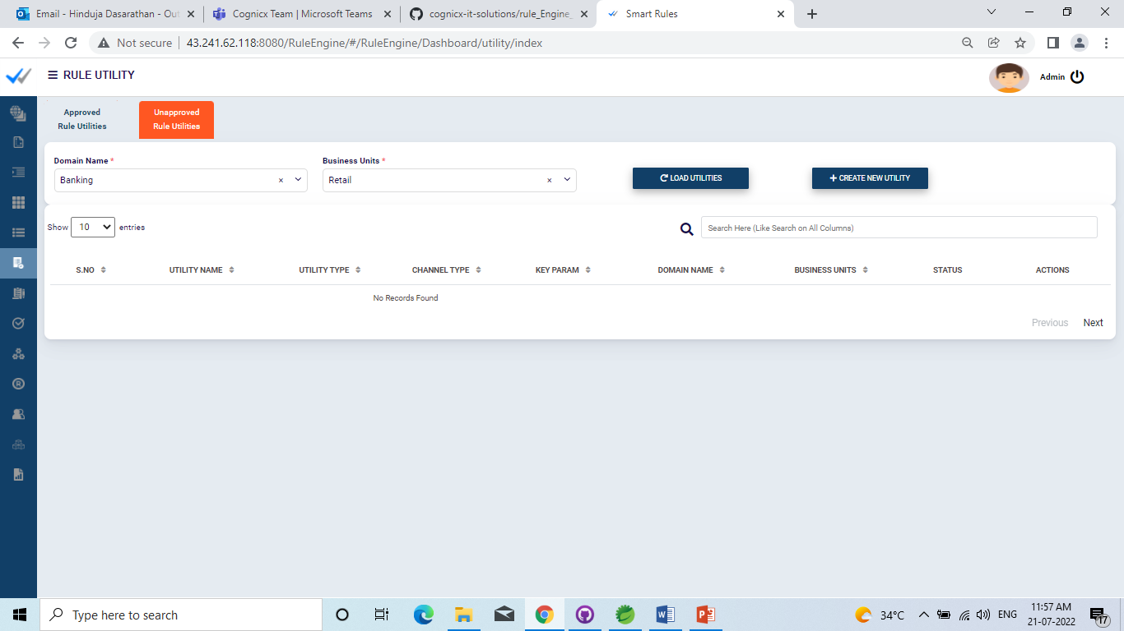

The following values are to be supplied during creation.

1. Specify the Rule Utility name
2. Specify the Rule Utility Description
3. Choose the Domain from the drop down
4. Choose the Business Unit from the drop down
5. Choose the Channel
6. Specify the utility type Normal or Range Check
   1. *Normal* - where the second parameter is a straight value condition.
   2. *Range Check* – where the second parameter i.e., column is a range field. Example: 0-10000, 10001-20000
7. Utility File - This is an excel file to be uploaded which has the table defining conditions in terms of row and column values and the corresponding output for the same.

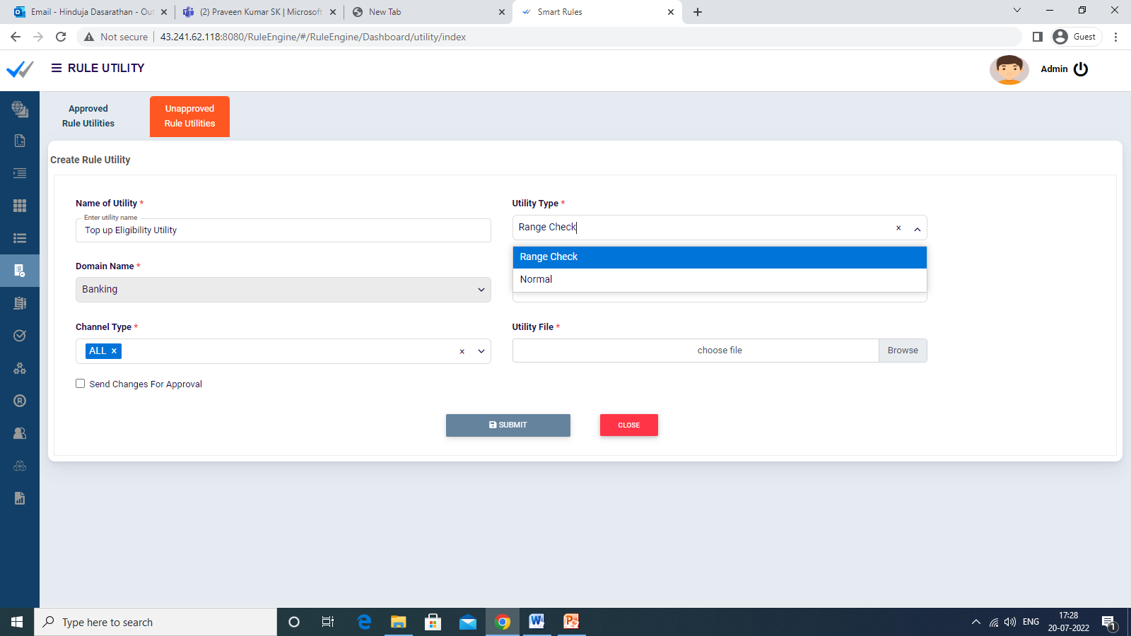

Below is an example for Range Check utility for Credit card type eligibility based on the Customer account type and their monthly average balance.

|  |  |  |  |
| --- | --- | --- | --- |
| Account Type/ Monthly average balance | 0-10000 | 10001-25000 | 25000-100000 |
| Savings | Easy EMI | Easy EMI | Platinum |
| Current | Easy EMI | Platinum | Millenia |
| NRI | Platinum | Platinum | Millenia |

For instance, if an Account type is NRI and Salary range is 15000, he will be eligible for Credit card type “Platinum” as per above utility configuration.

Once you specify above details, the created rule utility will be listed in the unapproved rule utilities section.

### 3.4.2 Send Rule Utility for Approval

On Click of send changes for approval in rule utility edit page, it will be sent for approval. This rule utility can be approved by another user who has the checker access in role for rule utility module.

### 3.4.3 Rule Utility Changes Approval Screen

In Rule Utility Changes Approval Screen, the rule utility to be approved by user with checker access will be listed, from where the user can approve or reject it. The list will not show the rule utility created by the current user.

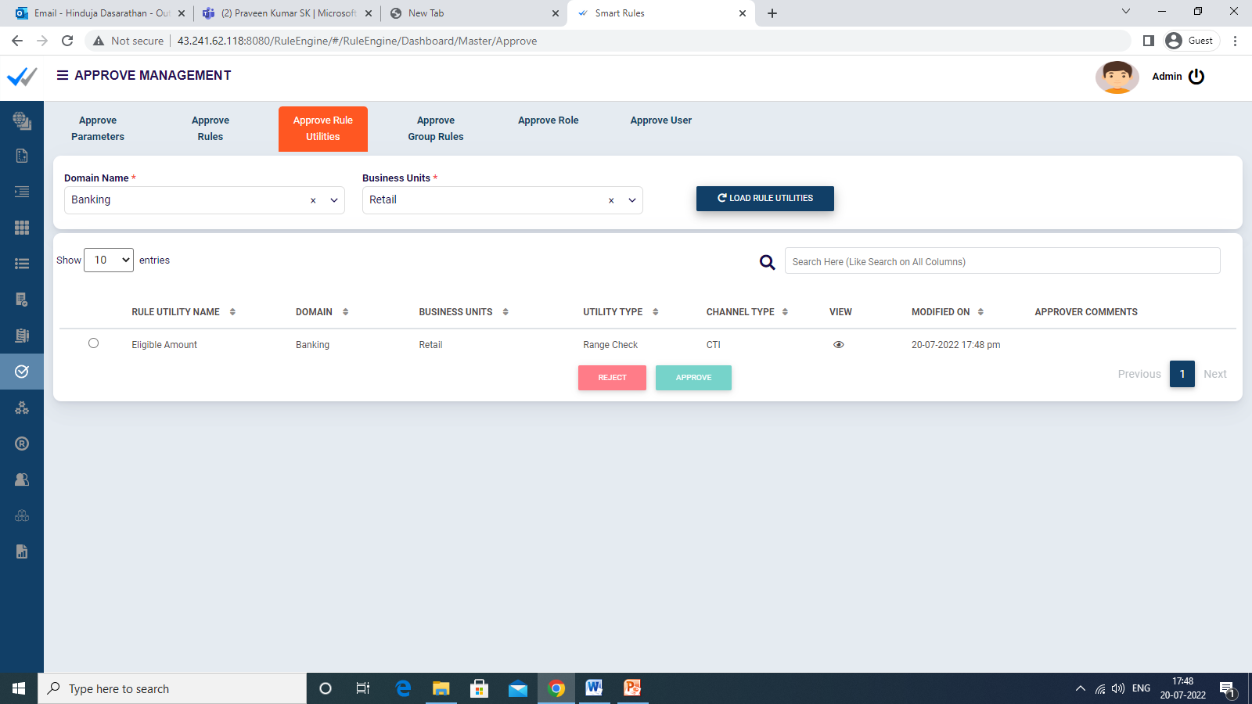

### 3.4.4 Approved Rule Utilities

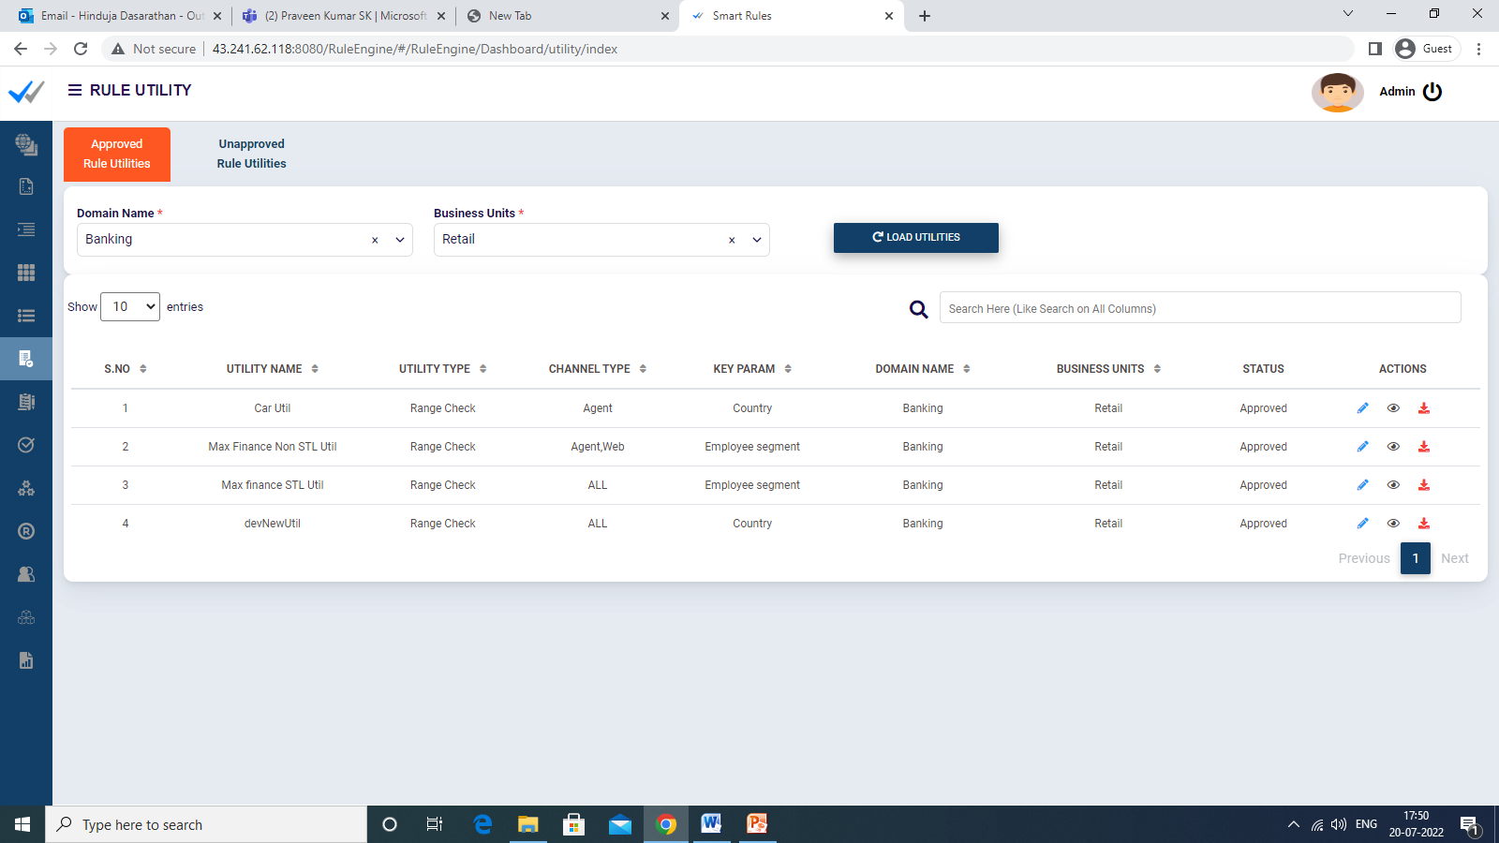

This screen will list the already approved rule utilities in the system and can be executed using the simulator page. The user can also edit the same and it can be sent for approval again.

## 3.5 Group Rule

Rules that are approved can be grouped together based on the need as a rule group. These rule groups, once approved allows execution of the multiple rules in the group in a single run of the rule group.

### 3.5.1 Group Rule - Create

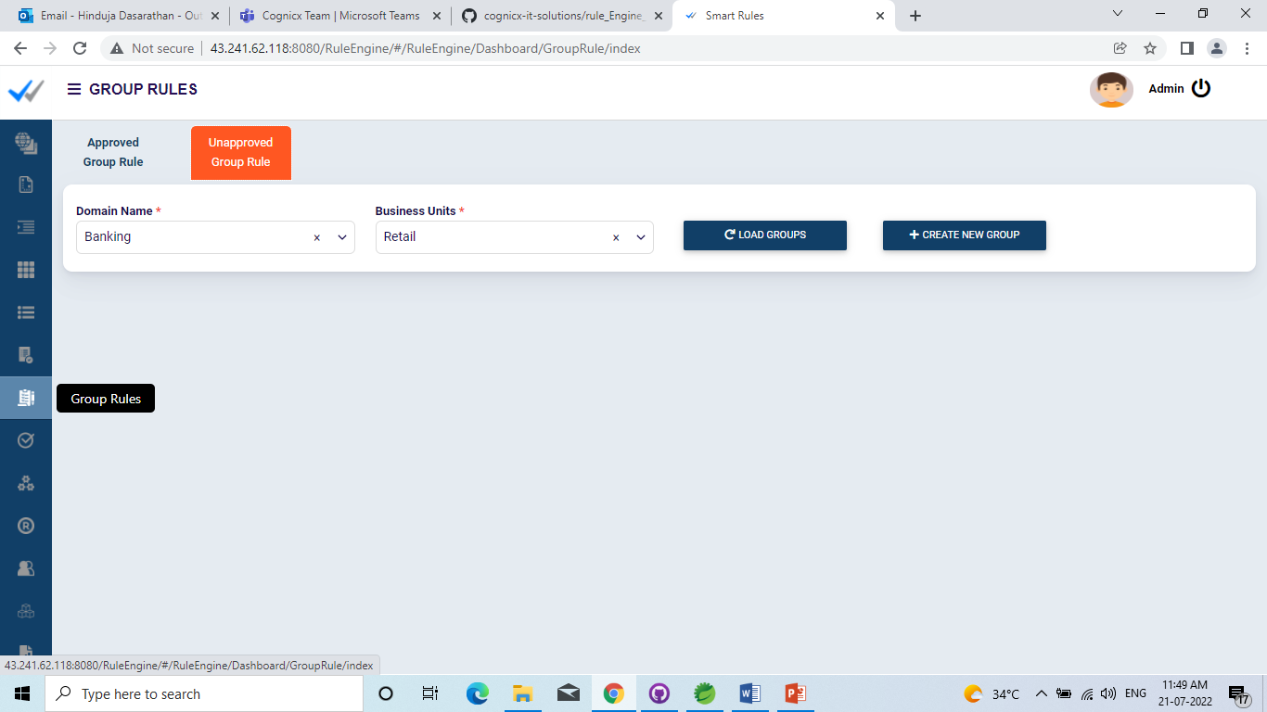

While creating a rule group,

1. Specify the Rule Group name
2. Specify the Rule Group Description
3. Choose the Domain from the drop down
4. Choose the Business Unit from the drop down
5. Choose the Category and the Channel
6. List of Rules to be grouped – This shows only ACTIVE approved rules.

Once you specify above details, the created rule group will be listed in the unapproved rule group section.

­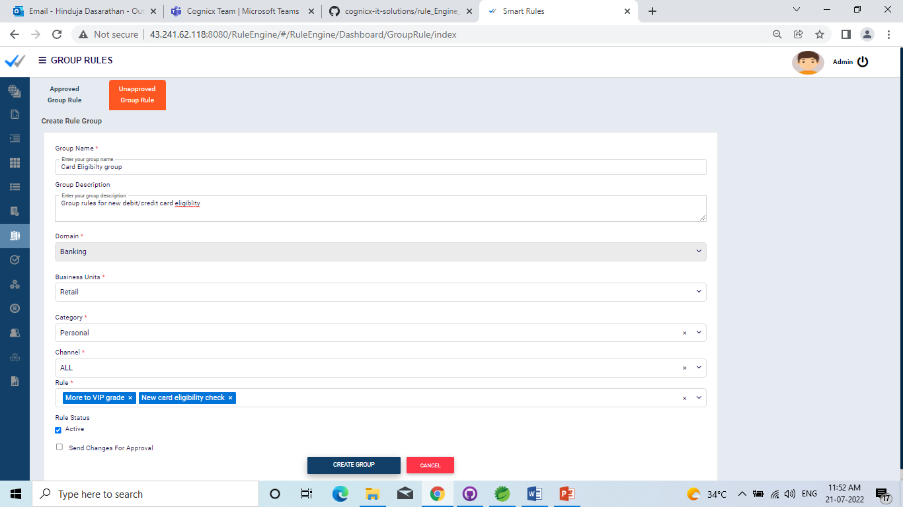

### 3.5.2 Send Group Rule for Approval

On Click of send changes for approval in group rule create/edit page, it will be sent for approval. This group rule can be approved by another user who has the checker access in role for group rule module.

### 3.5.3 Group Rule Changes Approval Screen

In Group Rule Changes Approval Screen, the group rules to be approved by user with checker access will be listed, from where the user can approve or reject it. The list will not show the group rule if any created by the current user.

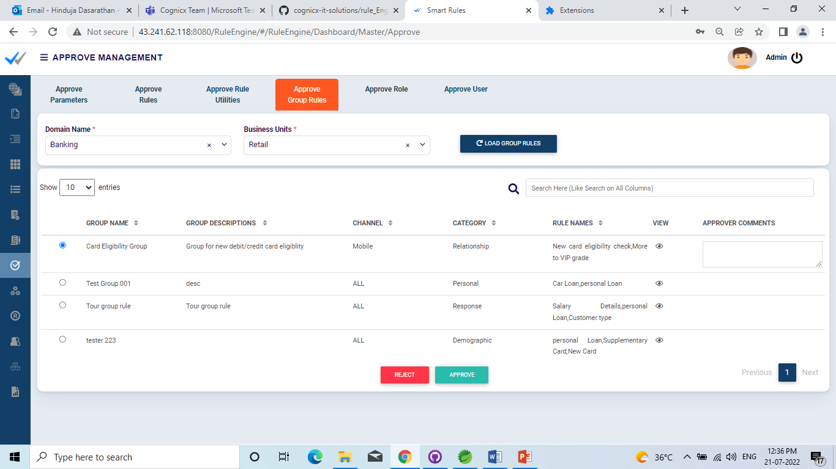

### 3.5.4 Approved Group Rules

This screen will list the already approved group rules in the system and can be executed using the simulator page. The user can also edit the same and it can be sent for approval again.

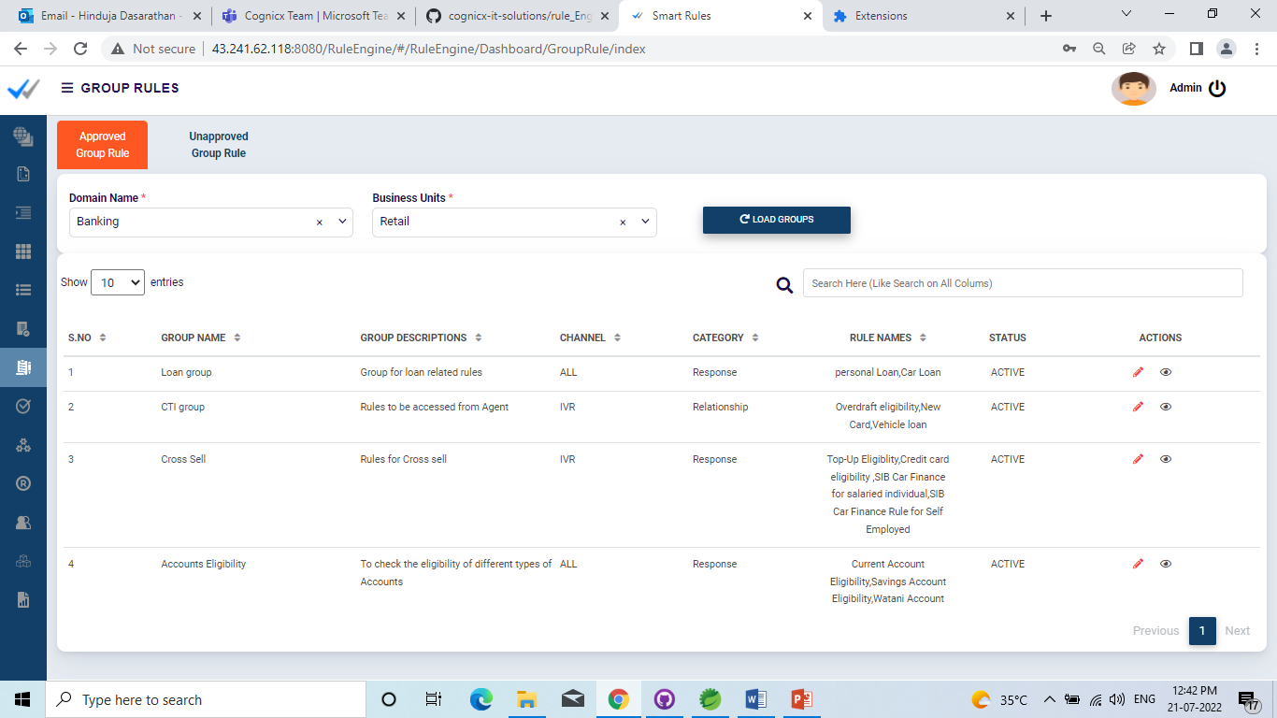

## 3.6 Simulator

In Simulator Screen, we can execute Rule / Group Rules/ Rule Utility. On click of view, we will get Input criteria to provide input values for the selected module. We can then simulate and verify the result.

The channel for simulation is to be selected appropriately and should be the one configured in the rule/ group rule/rule utility under execution, otherwise simulation will not be allowed.

In simulator screen we can select the type of Rule to be simulated in the below screen.

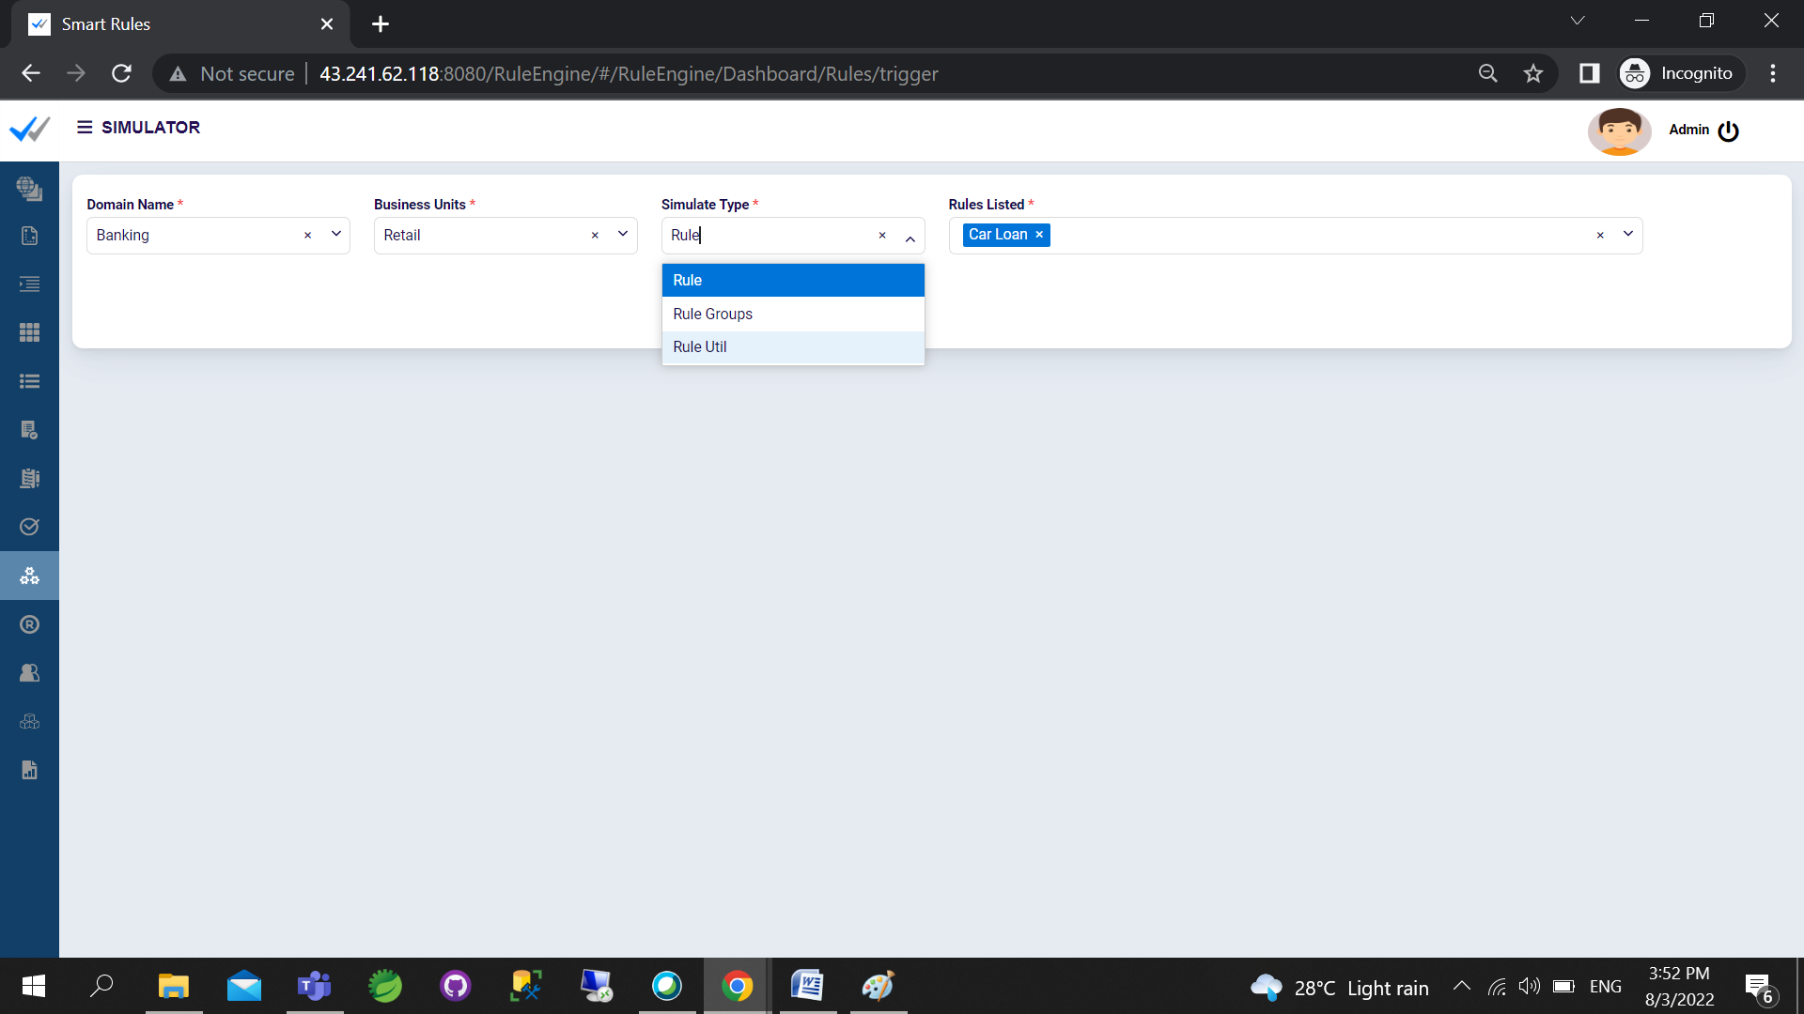

Once Rule is selected the configured conditions of the rule will be displayed in the simulation screen.

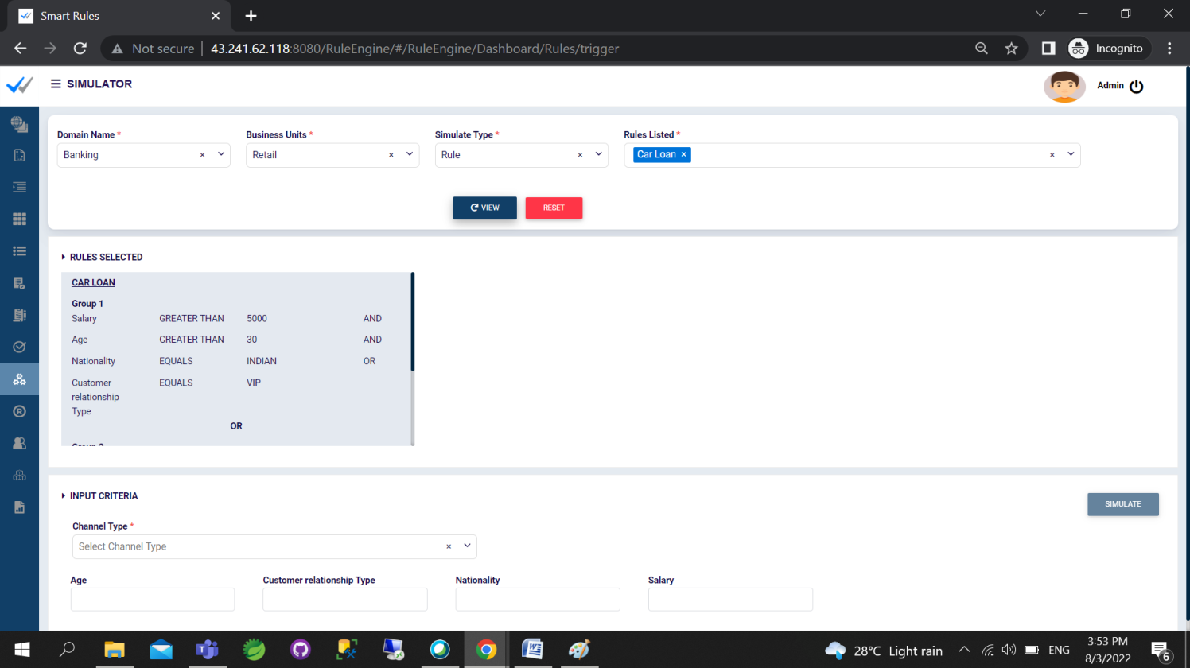

In input criteria choose the channel type and pass the values for Parameters configured and click “Simulate” Button.

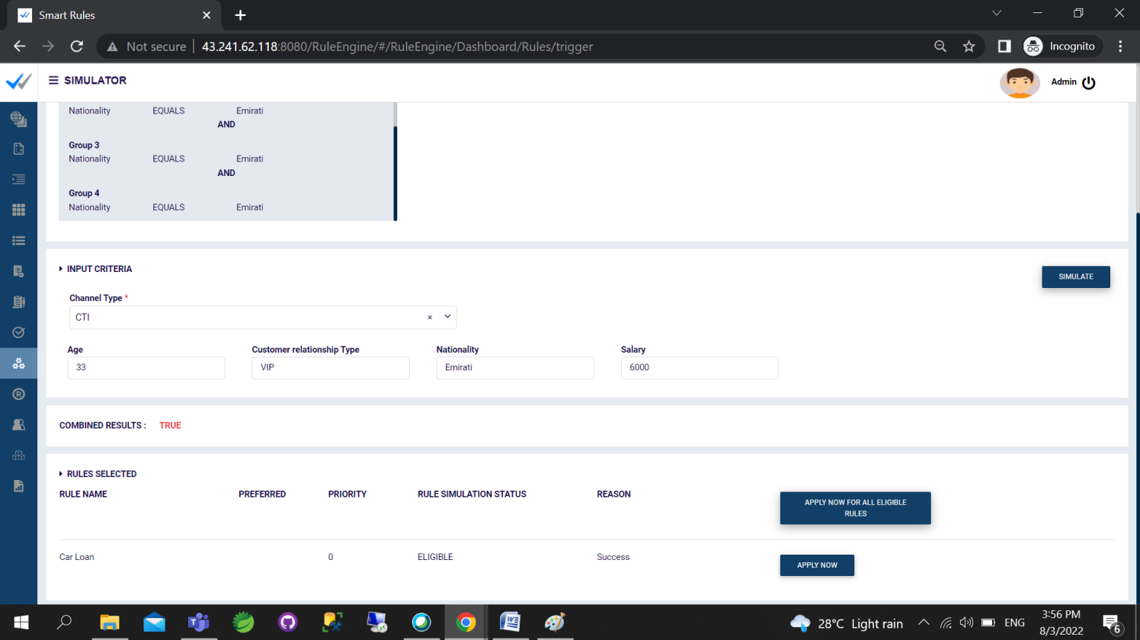

The simulator will give the result of execution of Rule / Rule Utility / Group Rules. In case of failure, it will show the failure reason as well.

## 3.7 Role Management

Roles can be created and managed, which can be associated to users of the application. Roles can be created by user who has maker privileges.

### 3.7.1 Role – Create / Edit

Role can be created by clicking on ‘Create New Role’ under the Unapproved Roles tab.

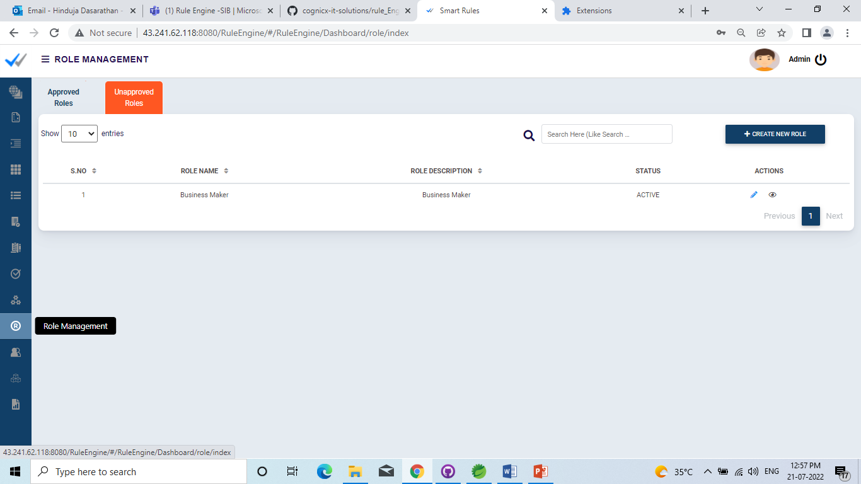

While creating a new role, provide the the role name, description. Select the required modules and choose the appropriate access permissions – Read, Maker, Checker

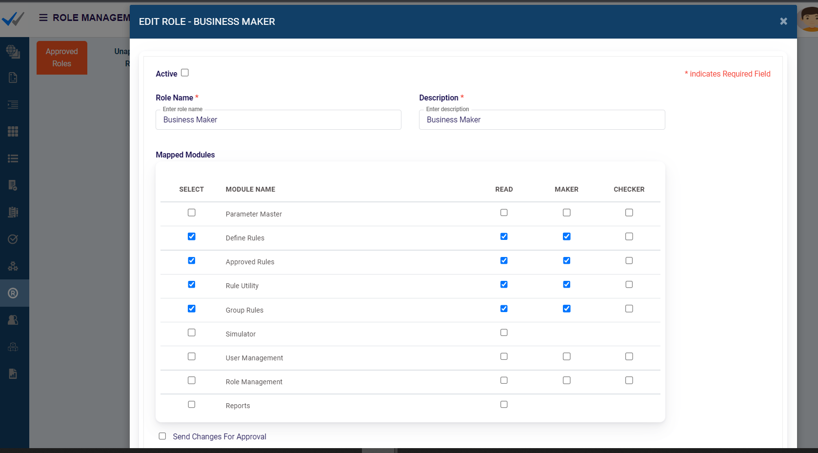

Once created, the role will be listed in the Unapproved Roles section.

The role can then be edited and sent for approval. Once approved, they can be associated to users.

### 3.7.2 Role Approval Screen

Role Approval Screen, the roles to be approved by user with checker access will be listed, from where the user can approve or reject it.

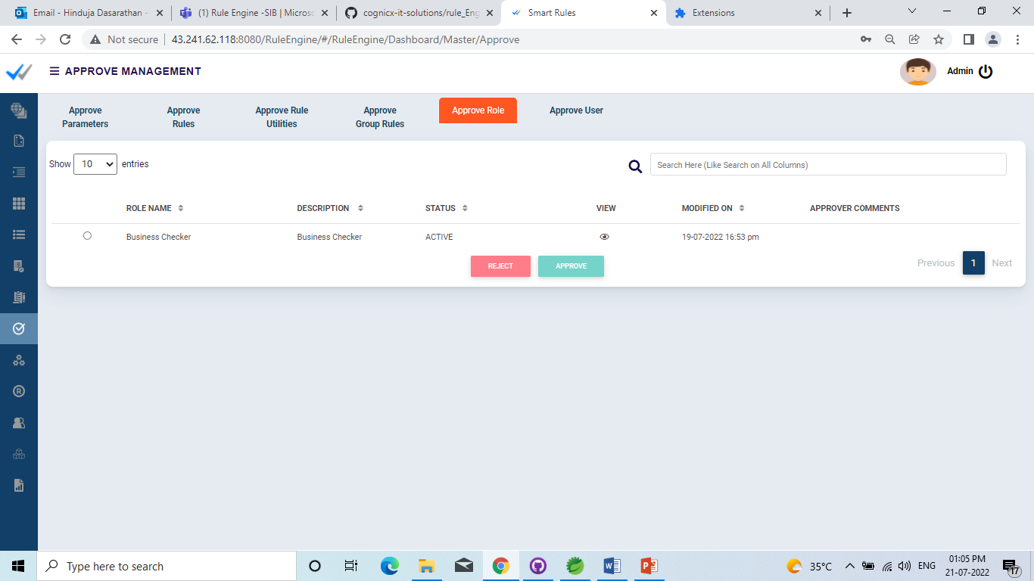

### 3.7.3 Approved Roles

This screen will list the already approved roles in the system.

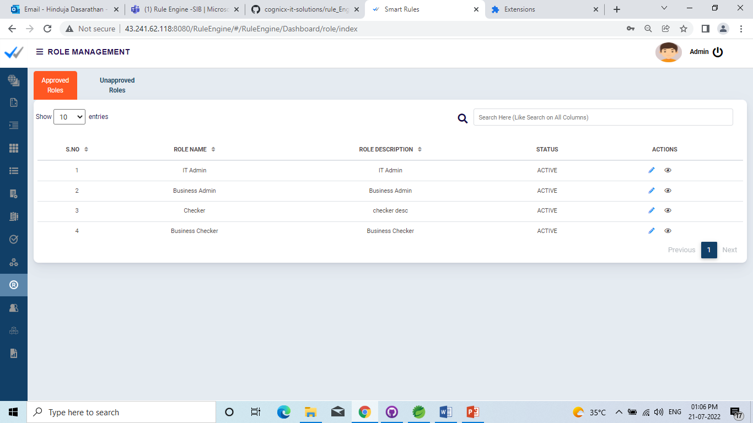

## 3.8 User Management

Users can be added and managed through user management.

### 3.8.1 User - Create

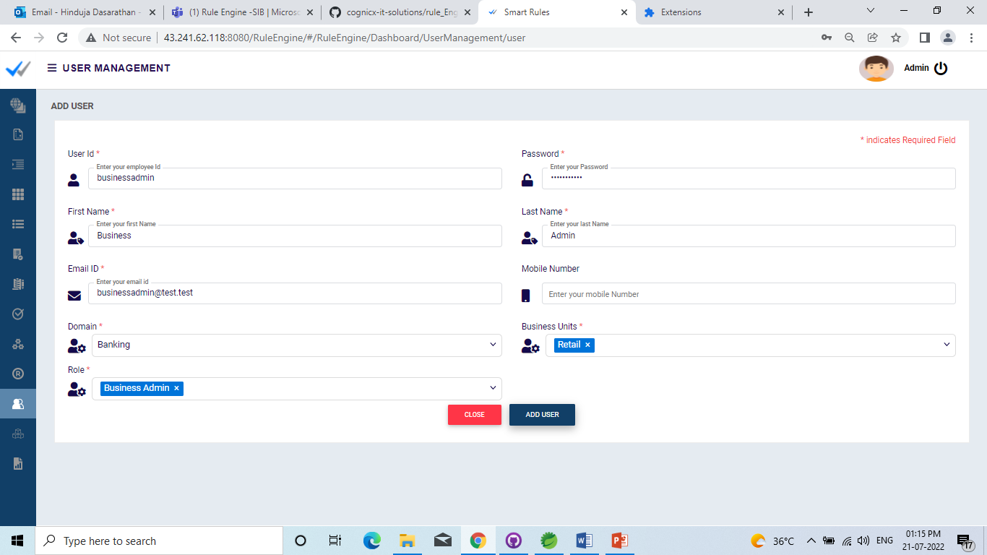

New user can be created by adding user Id, password along with Role details. Once created, it will be automatically sent for Approval

### 3.8.2 User – Approval Screen

The users to be approved will be listed in the approval screen.

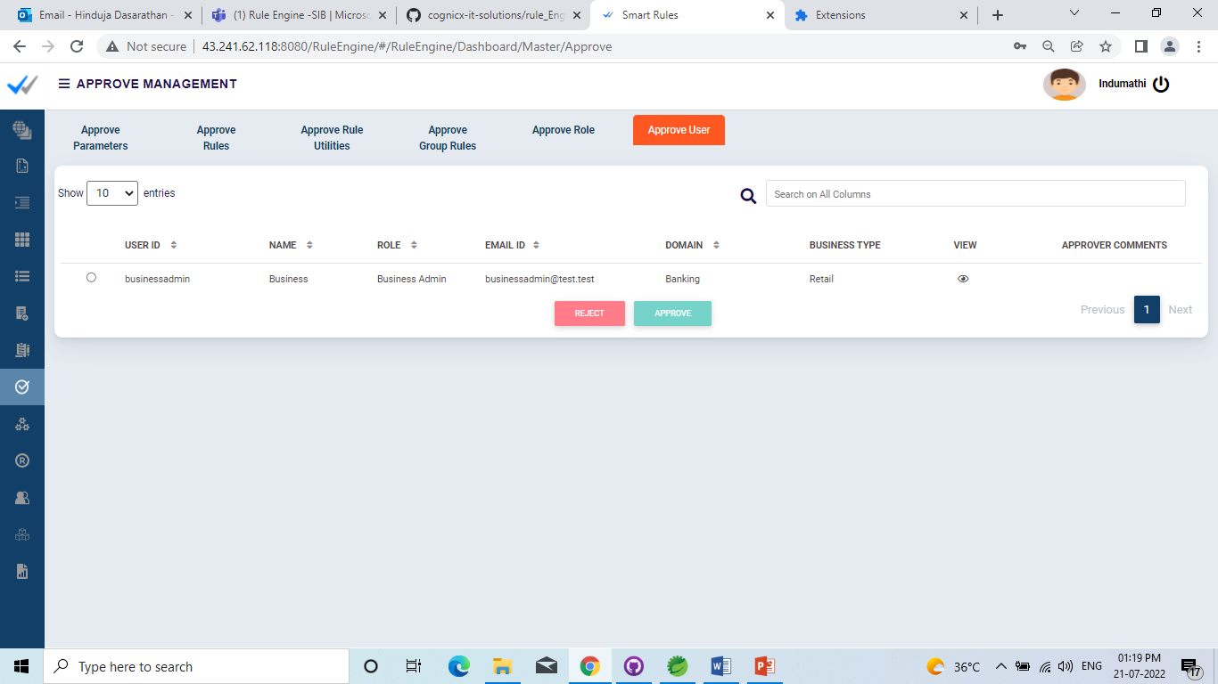

### 3.8.3 Approved Users

Once user get approved, it will be listed under User Management in the Users tab.

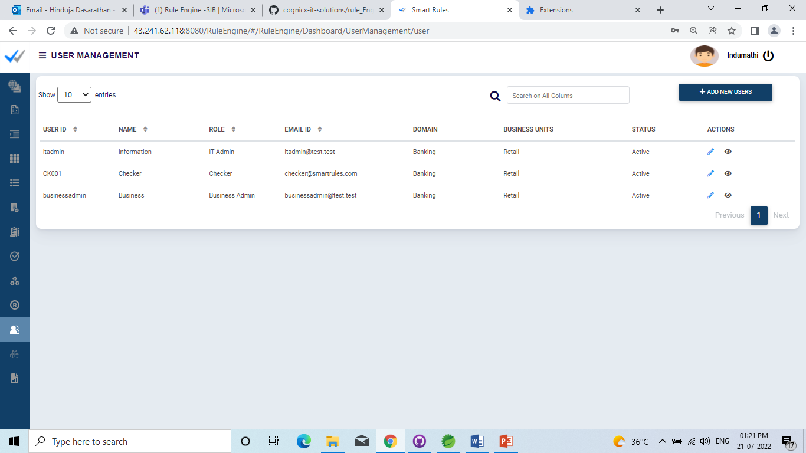

# Rule Engine Execute Rule API

The Execute Rule API is a RESTful API. This API use HTTP method POST and supports the JSON (JavaScript Object Notation) format for input and output.

Once the Rule is been defined in the UI, the same can be invoked by any other business module by invoking the executeRules API method.

**Sample URL**

http://<servername>:<port>/rule/ruleEngine/executeRules

## 4.1 Single Rule Execution – Sample Input and output

Rule Details

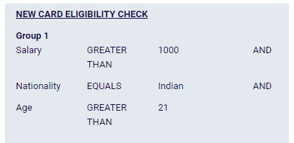

### 4.1.1 Single Rule Execution – Sample Input and output (Success Scenario)

Input Json format (Valid Inputs)

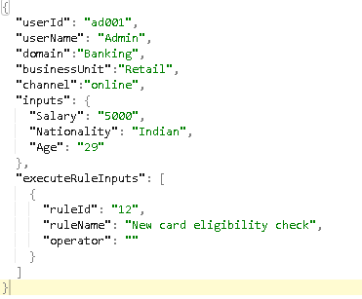

Output Json Format (Success)

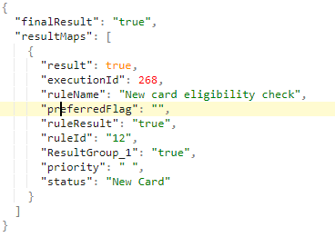

### 4.1.2 Single Rule Execution – Sample Input and output (Failure Scenario)

Input Json format (Invalid Inputs)

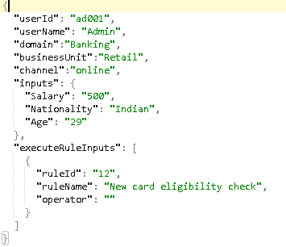

Output Json Format (Failure)

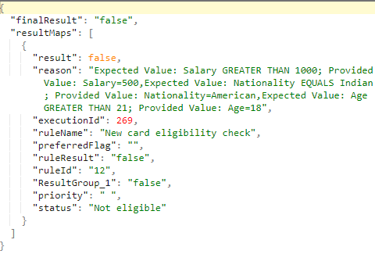

## 4.2 Multiple Rule Execution – Sample Input and output

Rule Details

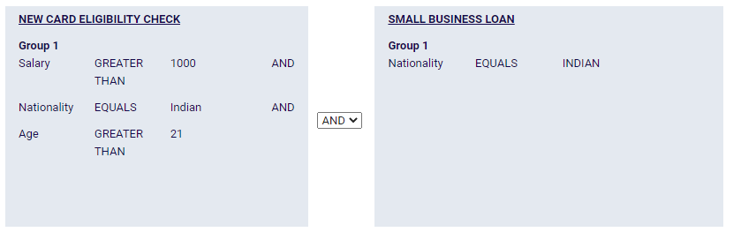

### 4.2.1 Multiple Rule Execution – Sample Input and output (Success Scenario)

Input Json format for two rule execution (Valid Inputs)

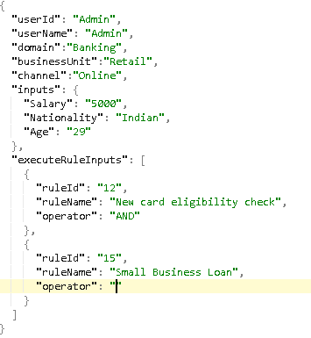

Output Json Format for two rule execution (Success)

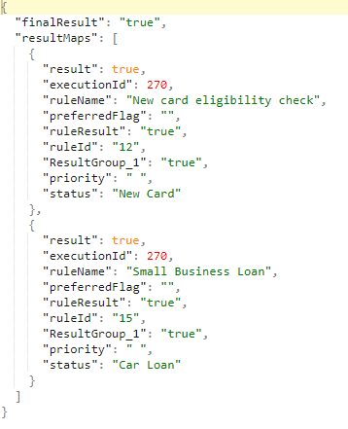

### 4.2.2 Multiple Rule Execution – Sample Input and output (Failure Scenario)

Input Json format for two rule execution (Invalid Inputs)

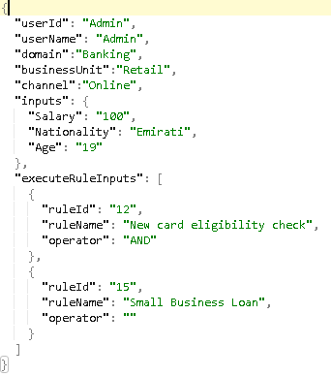

Output Json Format for two rule execution (Failure)

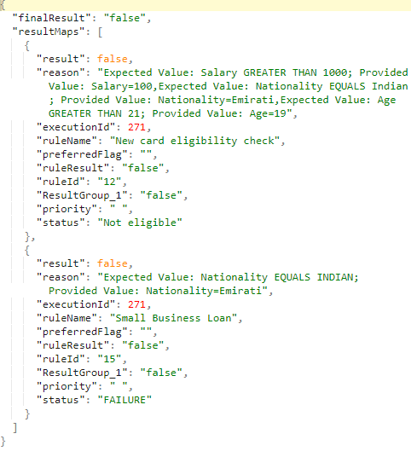

For Complete details on the APIs of Rule Engine is available API document.

# Rule Engine Dashboard

Summary View Tile shows rule details with the number of times it is executed, success count and failure count.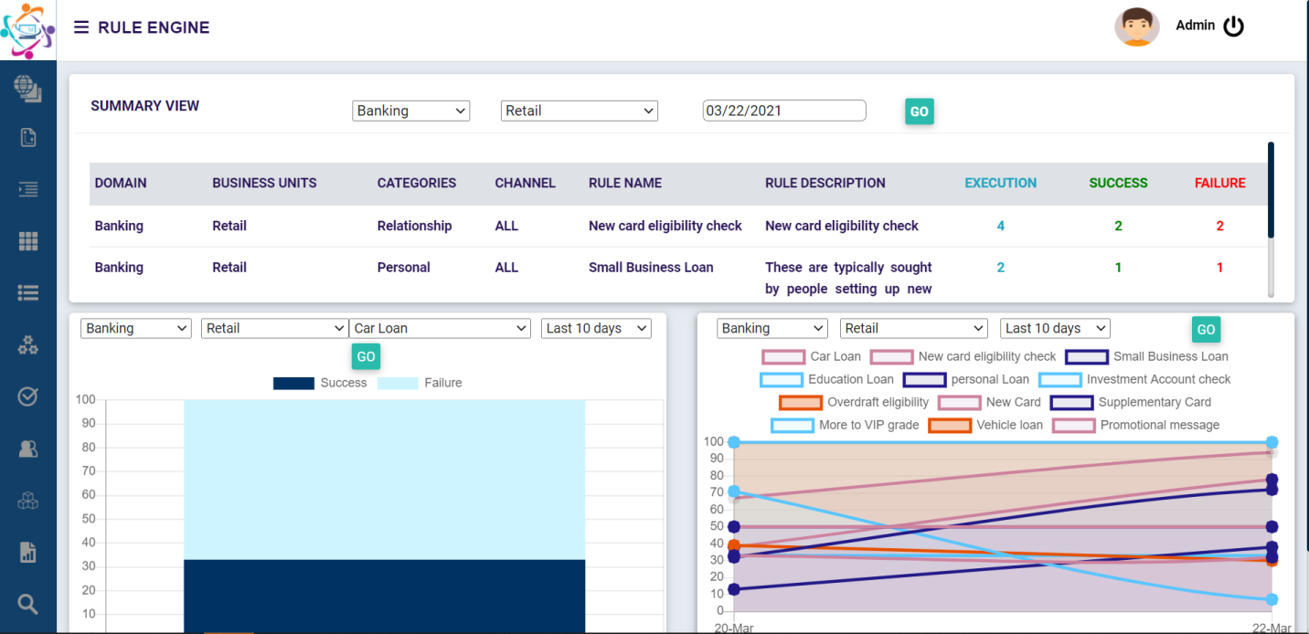

For a specified Domain, Business Unit and rule for a day wise view with total execution, success and failure percentages.

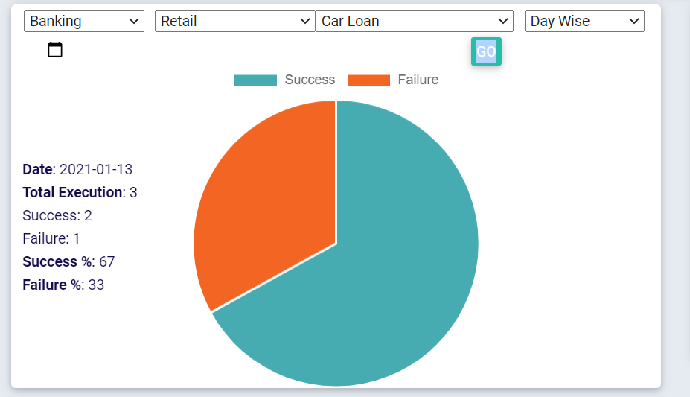

For a specified Domain, Business Unit and rule for a last 6-month view with success and failure count.

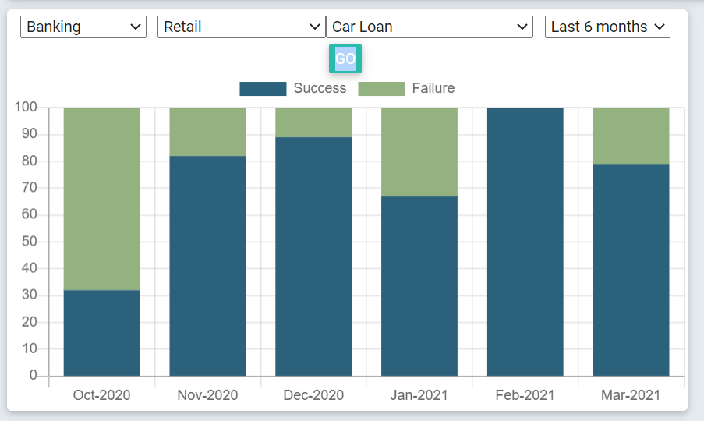

For a specified Domain, Business Unit and rule for a last 10 days view with success count.

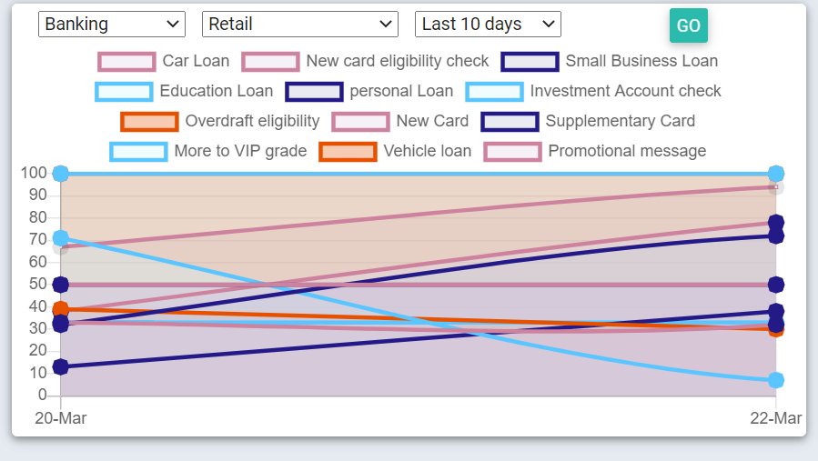

# Rule Engine Reports

## 6.1 Number of Rules configured Report

Number of Rules Configured report will provide a summary view and detail view of number of rules configured for the specified domain and business units.

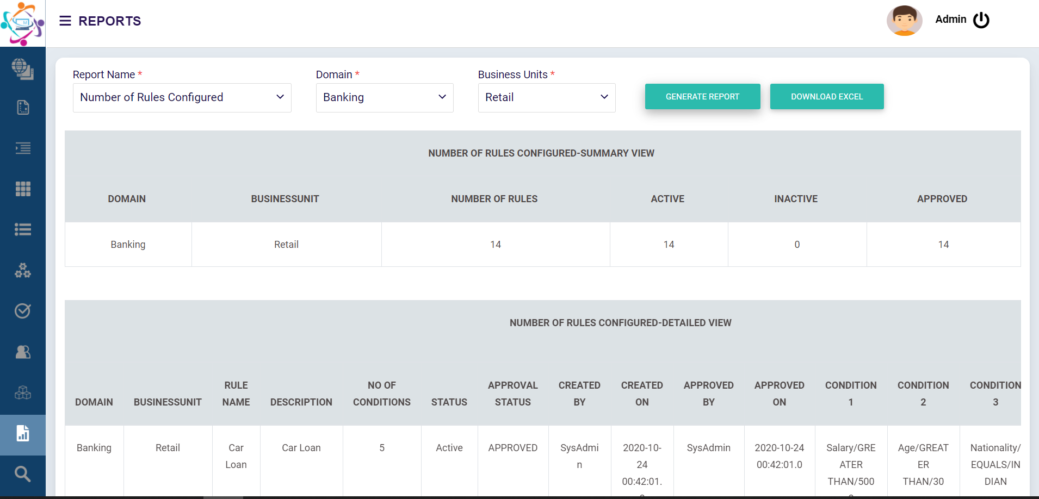

## 6.2 Frequently Used Rule Report

Frequently Used Rule report will provide a summary view and detail view of number of times rule is executed and their success and failure count for the specified domain and business units

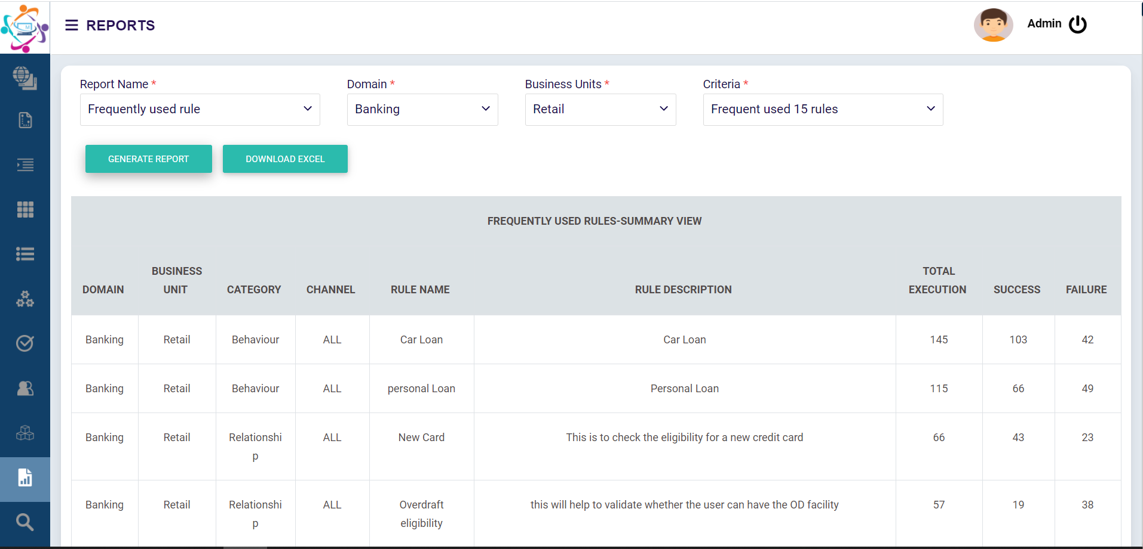

## 6.3 Failure Analysis Report

Failure Analysis Report will provide a summary view of failure execution of rule details and their reason of failure and executed by for the specified domain and business units

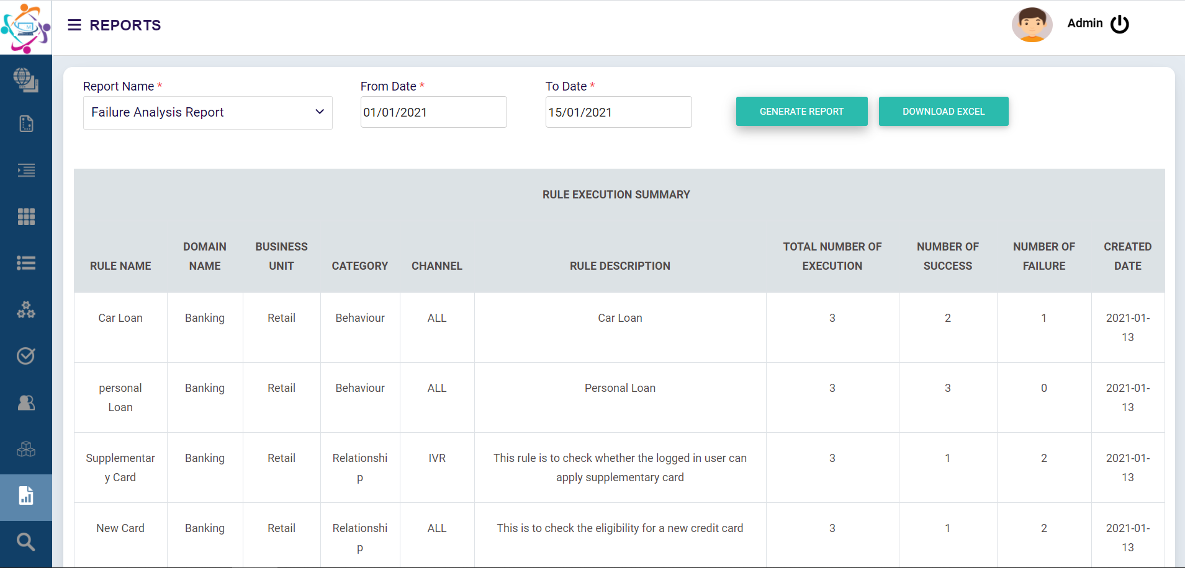

## 6.4 Lead Generation Report

Lead Generation Report will provide a detail view of lead generation, their channel and customer information of who executed the rule for the specified domain and business units

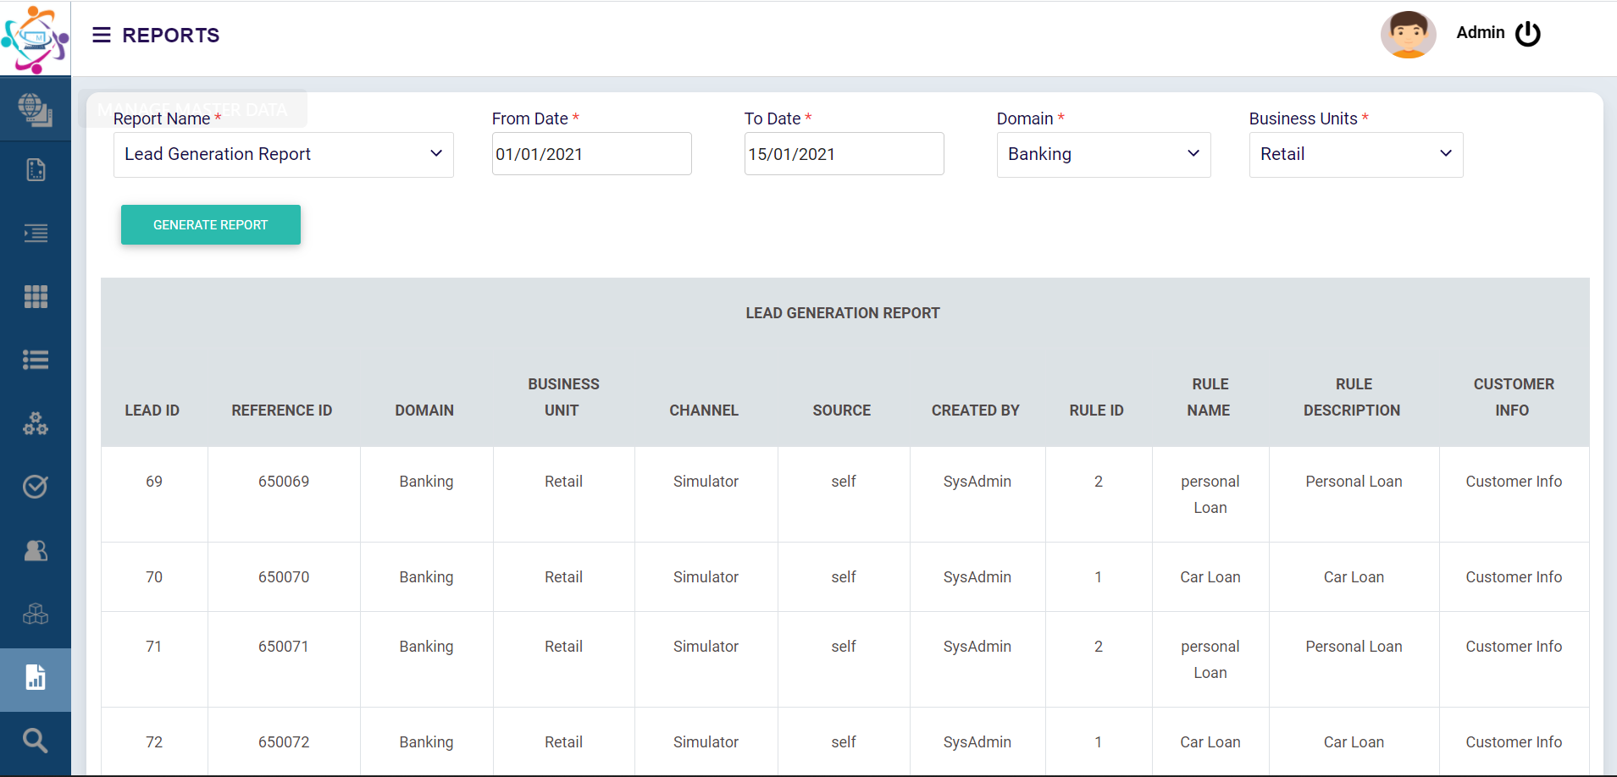

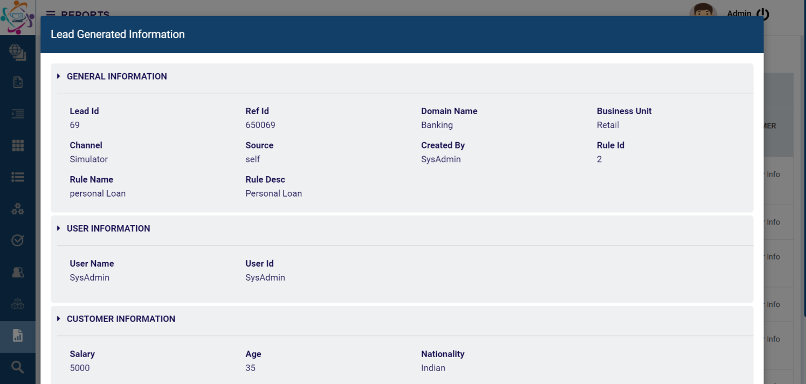

# Security

Following section details about the security aspects that are taken care by the Rule Engine.

* The APIs used by the Rule Engine are Secured by the HTTPS protocol. [While implementation, HTTPS interaction should be enabled through valid Certificate issued by a Certificate Authority]
* In addition, session-based Authentication is incorporated by implementing JWT (JSON web Token).
* And the APIs can be accessed only through the authorized or whitelisted IP addresses. From request from all other resources access will be blocked/forbidden.

# System Requirement

## 8.1 Hardware and Software Requirement for Rule Engine

|  |  |
| --- | --- |
| **Supported Operating Systems** | |
| Windows Server | windows Operating system |
| **Core Parameters** | |
| CPU | 2 CPU |
| RAM | 16GB RAM |
| HDD | 100 GB disk space |
|  |  |
| **Required Software** | |
| Java 8(8.0.2710.9) | |
| **Apache Tomcat (**9.0.39) | |
| **Data base** | |
| Microsoft SQL server (Latest) | |